

­

Javeria (CT-004), Qandeel (CT-029), Yasir (CT-036)

Project by:

Sir Waseemullah

Submitted to:

PROJECT REPORT

RTR

THE RESCUED

RESCUING

**Test Report Introduction:**

This RTR Test Report provides a summary of the results of test performed as outlined within this document.

**Testing summary:**

**Test Type:** **Functional Testing**

Testing the features and operational behavior of RTR to ensure they correspond to its specifications. Here we ignore the internal mechanism of a system or component and focuses solely on the outputs generated in response to selected inputs and execution conditions.

**What is our goal of functional Testing?**

The goal of Functional Testing is to verify whether our project meets the intended functional specifications mentioned in our development plan.

**Tools used:**



Jest is a delightful JavaScript Testing Framework with a focus on simplicity. It works with projects using: Babel, TypeScript, Node, React, Angular, Vue and more!

**Why we choosed Jest ?**

Top features are:

* Automatically finds tests
* Automatically mocks dependencies
* Runs your tests with a fake DOM implementation
* Runs tests in parallel processes

**TEST #01: Logging Functionality Testing**

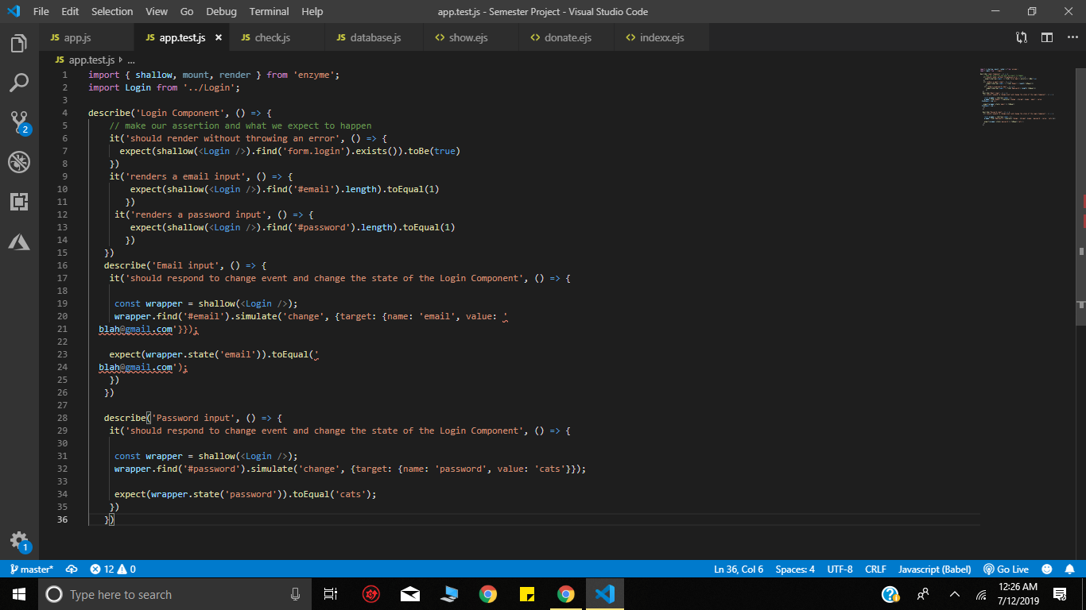

**Test Result:**

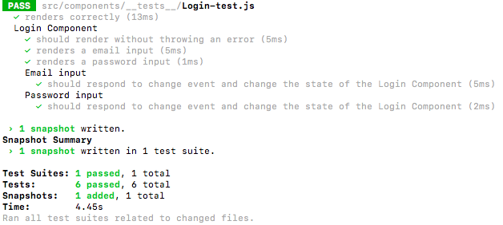

**Test #02: Modal Testing**

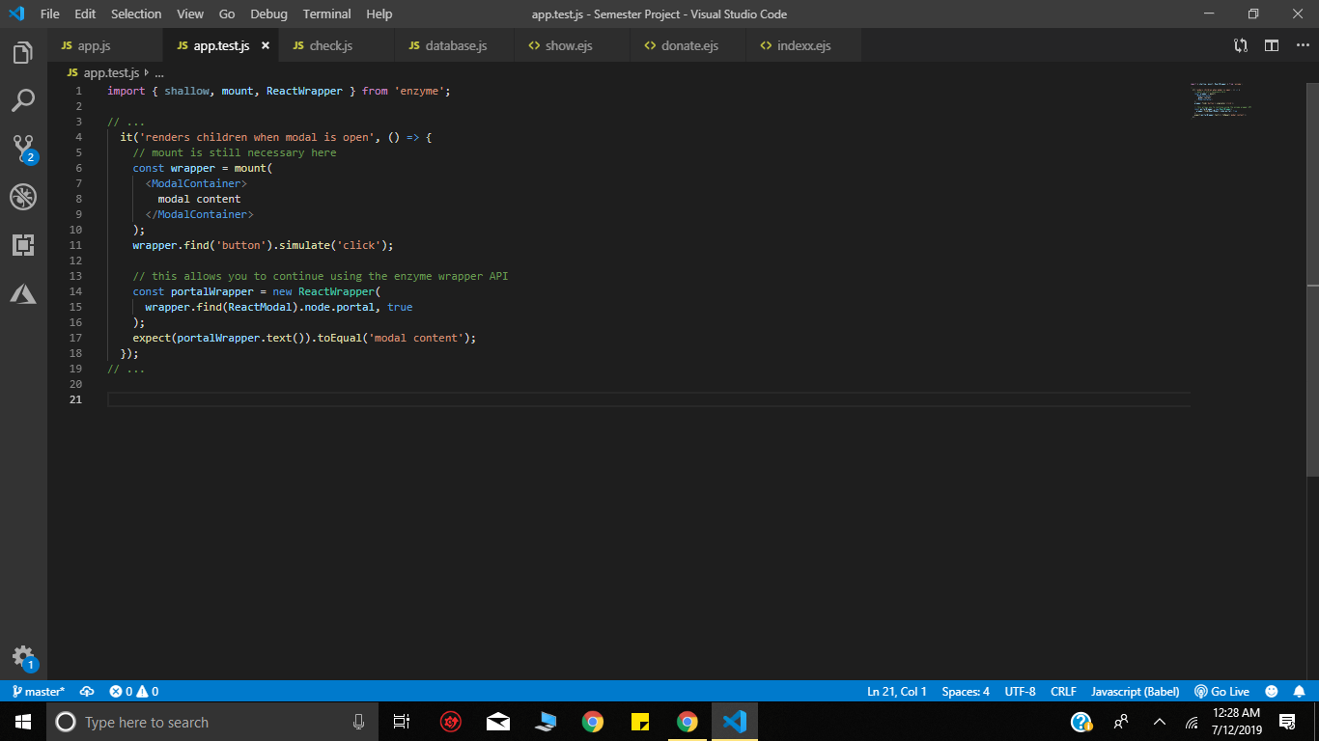

**Test Result :**

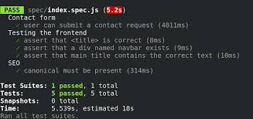

**Test #03: Form Testing**

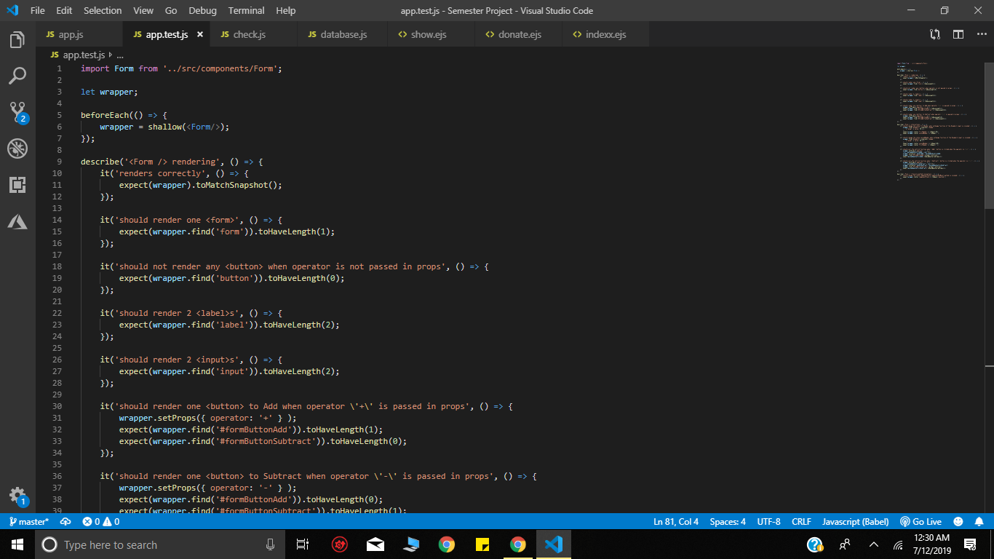

**Test Result:**

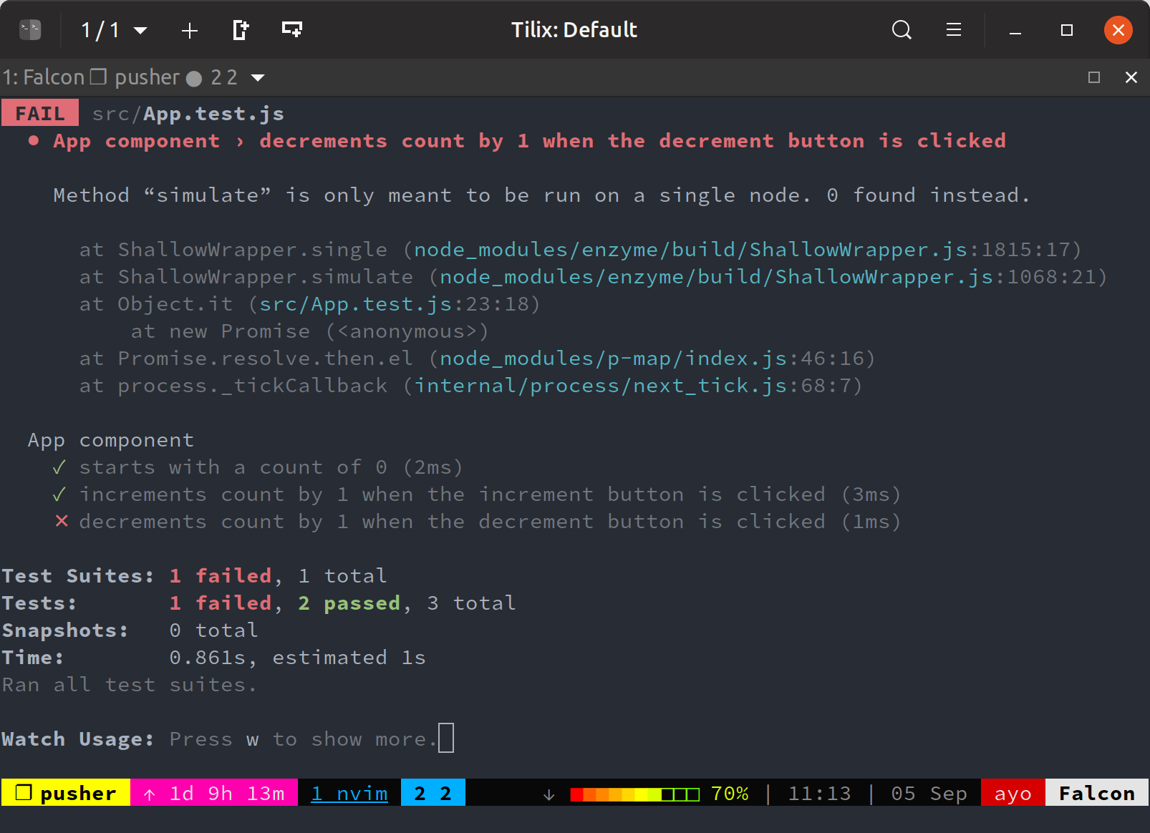

**Test Type:** **Usability Testing**

Before a new product is released, explorative usability testing can establish what content and functionality a new product should include to meet the needs of its users. Users test a range of different services where they are given realistic scenarios to complete which helps to highlight any gaps in the market that can be taken advantage of and illustrate where to focus design effort.

**Tools Used:**



First click testing of screenshots and visual designs ensures that users get started on the right foot when they hit our website.

**Test Result:**

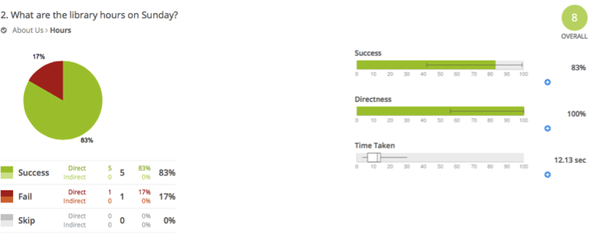**s**